The South African School Administration and Management System (SA-SAMS), is designed for the South African Education Sector and is therefore policy based to standardise implementation across all provinces. To keep the system valid and data credible it will be updated with the latest requirements to assist schools with administration and reporting.
2019 Curriculum settings will be available on Version 18.2.0
Changes on 18.1.3:
This version contains the following updates:
- 2019 Calendar
- Updated promotion requirements for dyslexia
- Updated Password control to address system date challenges (this is to assist schools that amend the system date)
- Update subject requirements for Free State pilot schools
2018 Year End Functions:
To prepare the database for 2019 the following year end functions need to be completed:
- Complete promotion / adjustment decisions (Screen 12.3.18)
- Check that all marks are correctly captured on 12.3.12 (Marks cannot be changed in 2019)
- To complete the Grade 12 year capture -1 for Term 4 exam task.
- Complete the promotion/ adjusted decisions on 12.7.18
- Year-end function: closing off 2018 in preparation for 2019 (Screen 3.19)
- THIS PROCESS MUST BE DONE IN THE 2018 CALENDER YEAR TO ENSURE THAT ALL DATA IS AVAILABLE IN 2019.
- Ensure that Learner Promotion/adjusted Decisions are processed on screen 3.18. Capture any changes by Circuit/District Managers.
- Do not archive learners before this process as it will remove them from any reports and statistics.
- Continue with year-end process after all mark and promotion decisions were completed.
- Step 1: Copy the database and keep as a back-up database.
- Step 2: Open Screen 3.19. The year showing is when the last promotion process was completed.
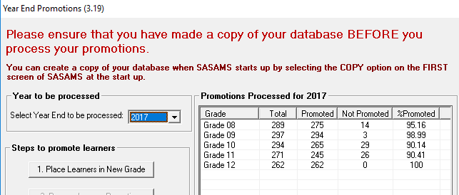
- Step 3: Change the year to 2018. If the screen is blank it is an indication that the 2018 promotion was not completed, continue as follows:
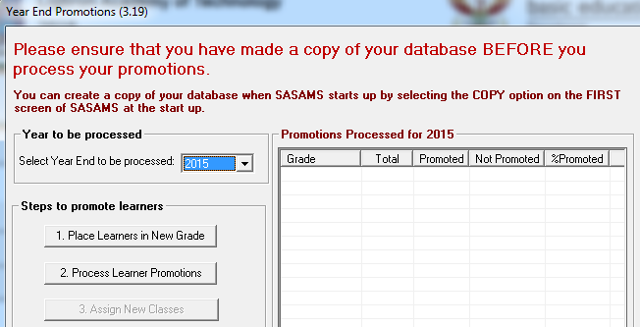
- Step 4: Click on ‘Place learners in New Grade”
  - if 12.7.18 was completed it will instruct you to go to “2. Process learner promotions”
  - In case of the Curriculum module was not used please select the learners that are promoted
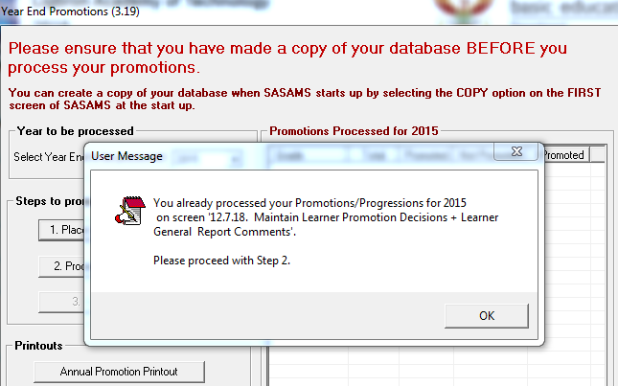
- Step 4: Click on “2. Process learner promotions”.
  - The promotion statistics for 2018 will be pre-populated.
  - The following step is irreversible and cannot be fixed. IN CASE OF NO MORE CHANGES – continue follows:
  - Tick the confirmation box At the bottom and then proceed to click on “Process Promotions”. Click on “Done” to exit screen
  - This process will archive all learners in the exit grade i.e. Gr 7 and Gr 12
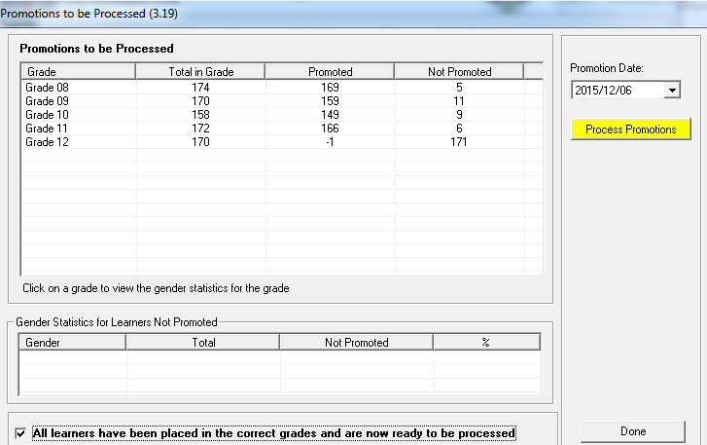
- Step 5: You will now notice that the statistics appear on the opening screen for 2018. All learners are now assigned to the next grade for 2019.
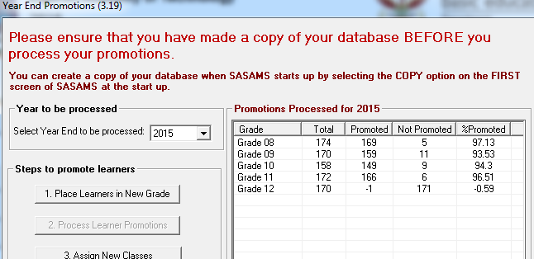
- Step 6: Assign learners to new register classes for 2019.
  - Click on the Grade – all the CURRENT learners in the grade will appear
  - Select the class on the bottom left window, then click on the learners that are placed in the class. If there is only one class then tick the box “Select all”
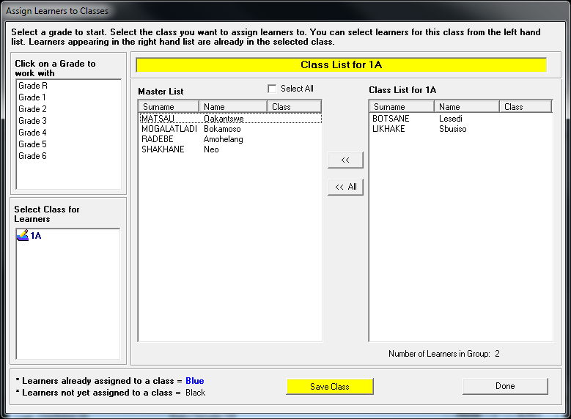
  - Print Class lists on 3.1.6 and 3.1.7
  - “Future learners” will only be shown on the class lists and attendance register after the learner is selected and processed.

- Access to previous year’s reports, schedules
- Learner reports
Select “Grade/Class History” screen 12.7.19
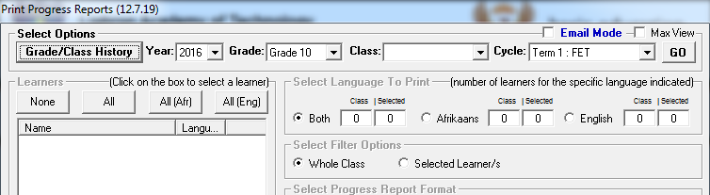
Select the grade that the learner will be in 2018.
Click on the required year.
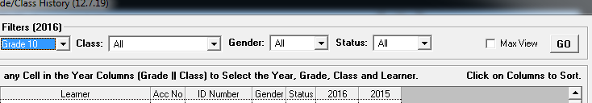
- Previous year’s schedules
- On screen 12.3.12.16 previous year’s mark schedules can be selected and printed. Available if security setting is on (Annexure B)
- Previous year’s promotion schedules can be viewed and printed from 12.9.12 and 12.9.15.
New functions available if security setting is available on 16.13 is “ON”:

