Directive
The South African School Administration and Management System (SA-SAMS), is designed for the South African Education Sector and is maintained by the Department of Basic Education (DBE), ensuring that it is aligned to education policies in. This route ensures standardised implementation and reporting across all provinces and aims to assist schools with their own data administration and reporting.
Changes on SA-SAMS emanated from requests received from users and various policy owners. These changes are tabled nationally at the EMIS Technical Committee with membership from all EMIS provinces. Changes on SA-SAMS are approved and signed off by the policy owner. Reported data and functionalities from SA-SAMS (as a national supported system) used for reporting is also annually audited by AGSA
Contents
This document lists challenges reported and solutions
- Terms does not show on 12.7.16.3 | - Schools to check and adjust dates for tasks/ activities in Term 2 and Term 3 on 12.3.11
- -2 showing for subjects on 12.7.16.3  - Cannot process marks | - Run the following App  - Please first install Errors and Ommissions if it is not installed (download it here: http://www.fsdoe.fs.gov.za/EMISPortal/Utilities.aspx or here: https://drive.google.com/file/d/15iYRkQg5fP6gSRi6kXq2D172mUo_eiwj/view?usp=sharing )  - Double click on the emq file . This will open Errors& Ommissions  - Browse for your SAMS database . (The last opened SAMS database will by default be selected )  - Click on Execute and confirm that you want to run the queries.  - Click on Ok and close Errors & Ommissions  - Also Note: When entering marks in 12.3.12 and you are entering -1 for activities in a task , please make sure that you save twice. The first time will be to save the marks to activities and the second time it will calculate the Task mark from the activities. (This will be fixed in a future release)
- Deployment errors | - Ensure that Pre Grade R has a subject assigned to it

Description | Screen | What is new / changed | Action by the school
Deploy learners without subjects assigned to them. | 17 | - Not able to deploy SA-SAMS database if all learners are not assigned with the core subjects | - School to assign the relevant languages, Maths and LO to all learners  - Assign subjects to Gr R and  - Create a subject for Pre Gr R and assign subject to learners  - School to update attendance of learners from grades that are phased  - Deploy database and print principal deployment form.  - Principal to confirm information of all learners, educators and Staff.  - Submit a deployed data base with signed off form.
Amended the validation that requires attendance to be captured for learners in all grades | 17 | - Able to deploy SA-SAMS database

- Ad hoc reason for school to be closed
Description | Screen | What is new / changed | Action by the school
Drop down list indicating reasons for school to be closed | 1.7 | - Schools can mark days that the schools are closed during the terms due to a variety of reasons. These days will be removed from the register and the number of days teaching updated  - Drop down list of reasons provided are:  COVID 19, Community Strike, Storms & Floods, Elections, Epidemic, Sport, Extra-mural,  - Other. | - School to capture the day that the school is closed and select a reason.  - The staff and learner attendance will be greyed out.
- Attendance modules updated
Description | Screen | What is new / changed | Action by the school
New reasons for not attending school – not on school premises | 2.12, 2.13, 3.3.3 | - New reasons for not able to attend school premises:  - Illness that requires a quarantine period (Communicable diseases e.g. Covid 19, measles etc)  - Not attending school as per timetable (learners attending alternative days)  - Approved as Comorbidity | - School to mark the educators, staff and learners as “Absent from premises” with the correct reason.  - Attendance calculations will be updated on SA-SAMS in following version as per directive.
New function to identify grades that are phased in | 3.3.3 | - Pop-up window to confirm the grades that are phased in | - Untick the grades that are not phased in  - Only the grades that are attending are visible for attendance capturing  - Attendance calculations are amended for grades that are not phased in

- Curriculum
Description | Screen | What is new / changed | Action by the school
Function to add “-1” to all selected learners | 12.3.12 | - Button to capture “-1” for all learners:  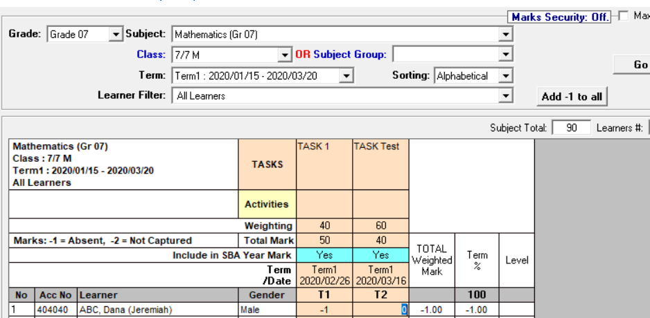 | - On 12.3.11 click on “-1 for all”. This will populate the whole column.  - To apply “-1 for all” for next column –in the column that need to be updated place curser on the first leaner’s capturing space, then click on “-1 for all”  - Click on save

- Curriculum corrections on 12.3.11 for March release
Description | Screen | What is new / changed | Action by the school
Fix weightings for  - LO Gr 10 & 11  - IT Gr 11 | 12.3.11 | - Term 2 fixed weighting corrected | - School to save weight validations  - Capture marks

- PERSAL validations
Description | Screen | What is new / changed | Action by the school
- Public schools PERSAL component number validation | 1.1 tab 2 | - PERSAL component number on TAB 2 – data field made compulsory  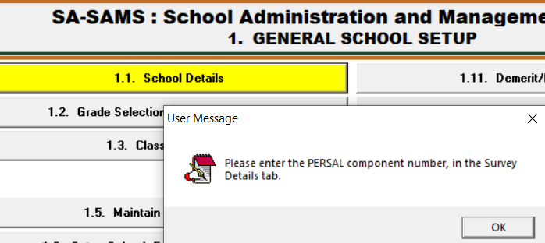 | - Click on Module 1.1.  - A pop-up message will appear if the “PERSAL component” data field is empty to inform school to complete the field.  - Capture the PERSAL component number and click on save.
- Independent schools – Staff PERSAL number clearance | 2.1 and 2.3 | - Staff are paid by schools and not being paid by the state. PERSAL numbers are removed. | - Click on educator and save to remove the PERSAL number. For audit purposes changes have to be done by the accountable official at school level.

Please feel free to contact the Provincial Province or contact the Provincial Province or send us a message dbesasams@gmail.com or Ramphele.M@dbe.gov.za or vanderwesthuizen@dbe.gov.za when reporting an error or require more information on SA-SAMS.

Kind Regards
The DBE SA-SAMS team

