Grade 12 SBA calculations on SA-SAMS
Schools need to complete the SBA marks on the printed Grade 12 schedules and P4 Oral marks. Please follow the instructions to use the schedules on SA-SAMS successfully.
There are two categories of subjects:
- A: Subjects with no oral or PAT marks: no adjustments needed as the SBA marks = the final marks on the schedules
- Subjects with oral or PAT marks: adjustments needed as the final marks on the schedules= SBA + Oral (P4) / PAT

A: Subjects with no oral or PAT marks | No adjustments
- e.g. Accounting  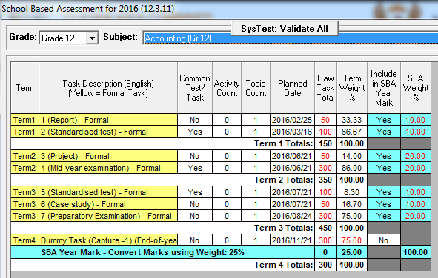 | - On 12.3.12 the SBA marks = the final marks as shown on the schedules  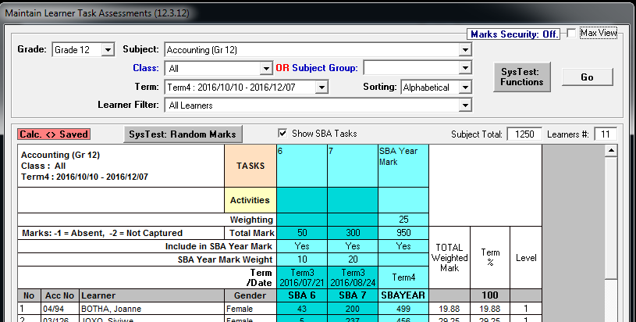
B: Subjects with oral or PAT marks | Adjustments needed on 12.3.11 (See next table)
e.g. Languages, EGD, Technical Subjects  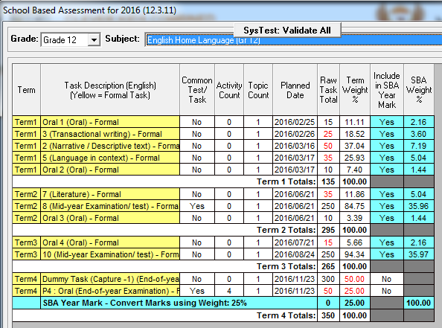 | - On 12.3.12 the final marks as shown on the schedules = SBA + Oral (P4) / PAT  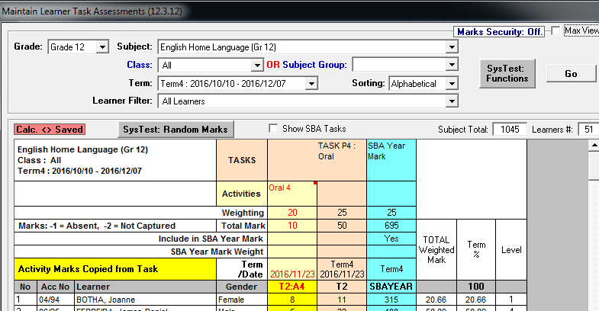

- Steps on how to change the SBA settings so that it only shows the SBA marks:
Step 1 : On 12.3.11 click on the blue task bar and click on “Edit Task”
Step 2: On 12.3.11 Select “Connect Marks to Specific Marks” and change to “100”
Click on “Save” and go to 12.3.12
DO NOT DO THE “WEIGHTS VALIDATION”
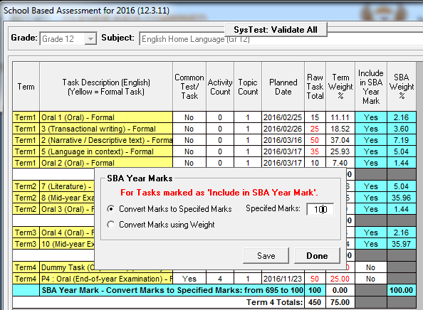

Step 3: On 12.3.12 open the Subject for Term 4. (Ignore the weights validation message)
The SBA column will be highlighted in red and the total will be the mark /100 for the SBA .
The P1: Oral mark is = 50
The PAT mark = 100
Print and Export the schedule for later reference ( afterwards the settings must be changed back)
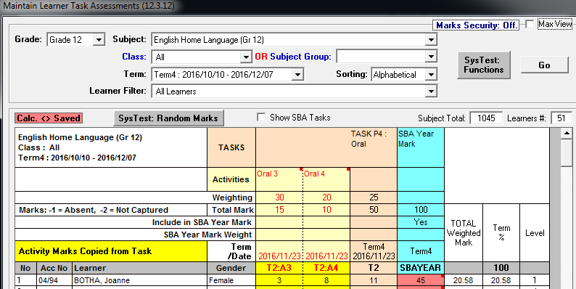
Step 4: On 12.3.11 Change settings back and validate the weights.
Click on the blue task bar and click on “Edit Task”
Select “Convert marks using weight” and change weight % to “25”
Click on “Save” and continue with weight validation
