Learner promotion using SA-SAMS
SA-SAMS assists schools with the learner promotion functionality and place learners in the correct new grades for the next year using menu 3.19. Important to remember is:
- The process should be completed at the end of the academic year after the promotion results were received from the district.
- This process is NOT REVERSABLE
- Historical data will only be available if this process is done using the function on Menu 3.19.
- This guide aims to assist schools so that they can complete the promotion process successfully.
HOW TO PROMOTE AND PLACE LEARNERS IN A NEW GRADE:
There are two procedures available on SA-SAMS:
- Promotion for schools using the Module 12: Curriculum
- Promotion for schools that did not captured any marks on the Module 12: Curriculum

- Promotion for schools using the Module 12: Curriculum
- Save the promotion decision that is generated on Menu 12.7.18 after all the marks were captured.
- Remember to change the “NP” to “P” for progression learners. Also add the reason for this decision.
- Save a copy of the school data base before you continue with promotion process because this process is NOT REVERSABLE
Step-by -Step instructions | Screen
- Continue with the promotion process  - Click on Menu 3 (Learner and Parent Information) and then Select Menu 3.19 (Process Learner Promotions).  - Change the “Year End” to 2016 and continue with Step 2 “Process Learner Promotions”  - (Step 1 was completed on saving Screen 12.7.18 ) | 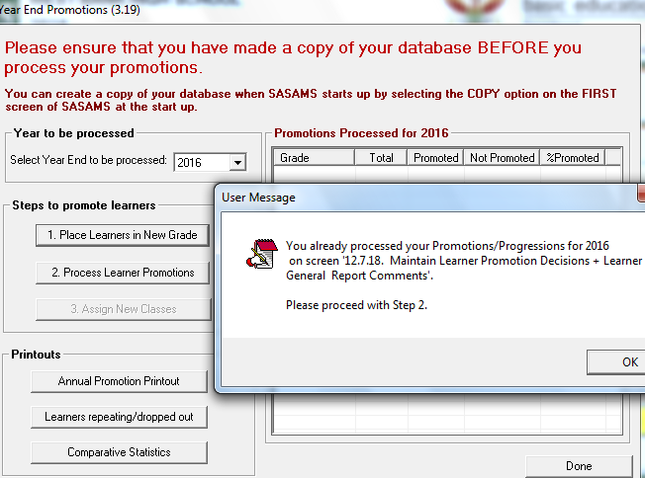
- Click on Step 2 “Process Learner Promotions” and check if  - When satisfied that the results are correct tick the box on bottom left of the screen to continue with the process.  - Click on “Process Promotions” and confirm on the popup screen to continue. | 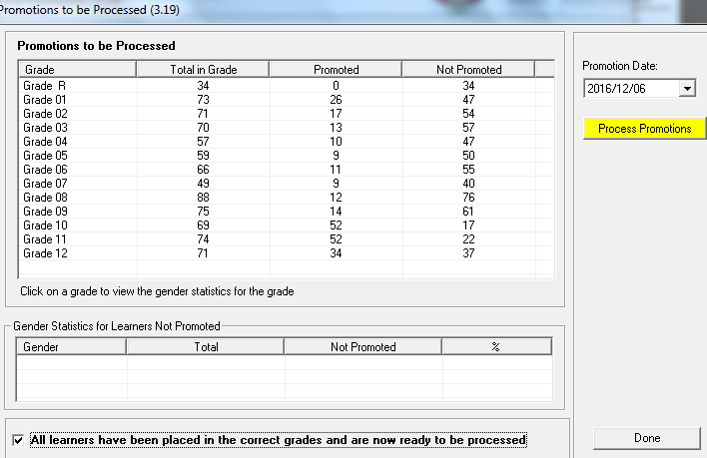
- Promotion statistics are available after the promotion procedure was completed.  - Promotion statistics and learner fail reports are available for printing. | 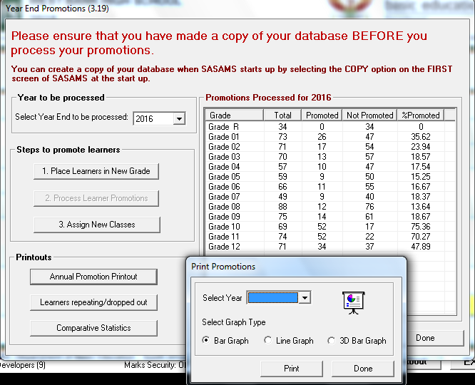
- Click on Step3 “To assign learners to the new classes”  - Click on the Grade and then Click on the Class.  - Click on the learner’s name that are placed in the new class  - Click on Done to exit the screen | 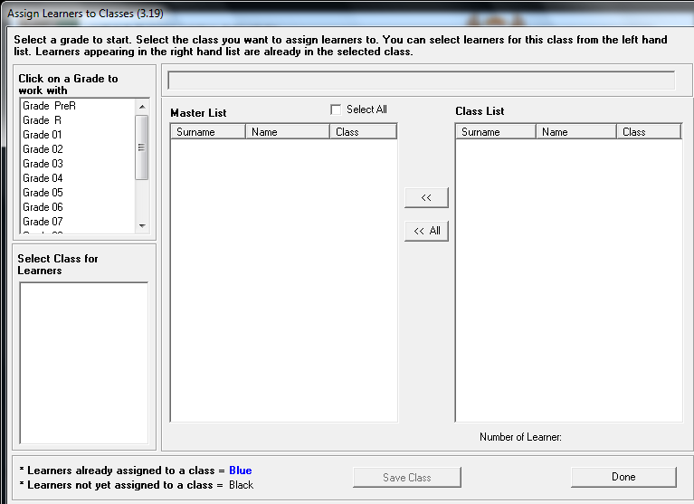

- Promotion for schools that did not capture any marks on the Module 12: Curriculum
- Save a copy of the school data base before you continue with promotion process because this process is NOT REVERSABLE
Step-by -Step instructions | Screen
- Continue with the promotion process  - Click on Menu 3 (Learner and Parent Information) and then Select Menu 3.19 (Process Learner Promotions).  - Change the “Year End” to 2016 | 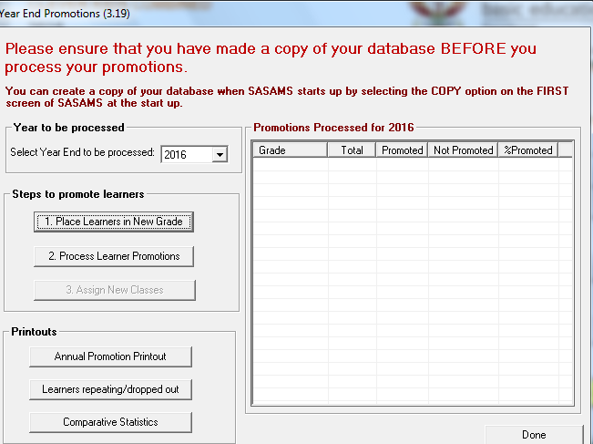
- Click on Step 1 “Place Learners in Grade”  - Click on a class to generate a class list. All Learners are set by default as non-promoted.  - Remove the tick next the learner’s name for all learners that are promoted.  - After this process is completed in all classes Click on “Save for processing” and click on Done to exit the screen. | 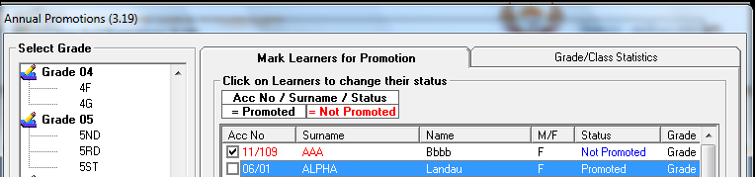
- Click on Step 2 “Process Learner Promotions” and check if
- When satisfied that the results are correct tick the box on bottom left of the screen to continue with the process.
- Click on “Process Promotions” and confirm on the popup screen to continue.

- Promotion statistics are available after the promotion procedure was completed.
- Promotion statistics and learner fail reports are available for printing.

- Click on Step3 “To assign learners to the new classes”
- Click on the Grade and then Click on the Class.
- Click on the learner’s name that are placed in the new class
- Click on Done to exit the screen

- Progression of learners will be captured for individual learners on Menu 3.1.1.  - Tick the box next to “ Learner Progressed to this grade” | 