How to resolve the data type Mismatch error
Step 1: Open your browser (Internet Explorer).
Step 2: Type in: http://www.thutong.doe.gov.za
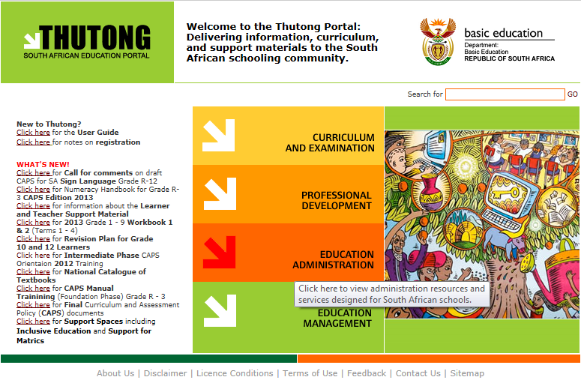
Step 3: Select Education Administration
Step 4: On the right side under latest version, select(version Mismatch 20.0.0) and download.
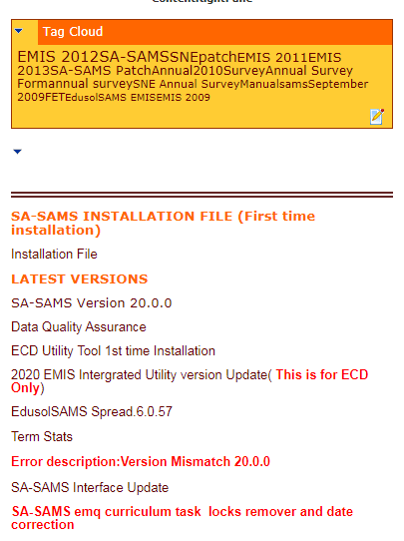

Step 5: Extract the file inside Named EdusolEmis (20.0.0).mdb.
- paste and replace the one on your C:\Program Files\EdusolSAMS Or on your C:\Program Files(x86)\EdusolSAMS
- 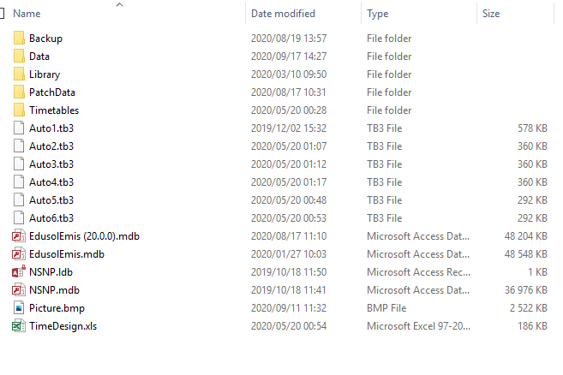

- If you still get the error after you did the first step then try virtualstore then:
C:\Users\Your profile\AppData\Local\VirtualStore\Program Files\EdusolSAMS Or
C:\Users\Your profile\AppData\Local\VirtualStore\Program Files(x86)\EdusolSAMS

