INTRODUCTION
- To be fully operational, SA-SAMS needs to be correctly set-up for the New Year. The checklist provided will guide the schools to close off 2020 and provide a checklist for 2021.
- Year-end promotion and roll over (3.19) need to be completed in 2020 to ensure full functionality in 2021.
- The 2021 Curriculum settings will be available in version 21.0.0.
CONTENTS OF THIS TIP:
To provide a tick list for the year end processes and 2021 settings in preparation for a operational SA-SAMS 2021:
- A: Check list of steps to be completed on SA-SAMS for 2020
- B: Lists and summaries for checking and verification & reports for Districts
- C: Previous year’s marks available
- D: Subject Updates (Available on version 21.0.0)
- E: Annexure –Promotion to be completed in 2020 for 2021 on 3.19
- F: Annexure– offline capturing options if security setting is switched on

A: Check list of steps to be completed on SA-SAMS for 2020
This checklist is designed to guide the schools to ensure that all processes are done correctly.
 | Screen | Function | Tick if checked
New Learners | 3.1.1 | Capture new learners with registration date as January 2021**  - Assign subjects to the learners after 21.0.0 is loaded
Learner promotion completed in 2020 | 12.7.18 | Confirm promotion decisions, identify progressed learners  Print statistical schedules (12.9.16)  Correct GET changed decision to be selected for schedule as well as learner report
 | 3.19 done once | Learners are promoted in 2020 to the new Grades for 2021  - Please make a backup copy before promotion  - Follow the instructions in the Annexure below as this process cannot be reversed.  - This procedure is required to ensure that historical information is kept
Learner updates | 3.1.1 | Archive learners that are leaving  - Gr 7 was automatically archived
 |  | - Gr 12 will be automatically archived according to SBA results – after capturing -1. Archive Gr 12 learners now that attained their NSC.
 | 3.1.5 | Place learners in new register classes
 | 3.1.8 | Update LOLT of learners (Gr 4)
 | 6.3 | Print pre-populated learner & Parent profile forms to confirm information ( Re-registration) | Parents to confirm update changes on SA-SAMS
 | 12.1.15 | Assign subjects to the following learners  - learners entering a new phase  - New learners  Check for errors on 12.1.19 | Available with 21.0.0
 | 12.1.16 | Assign learners to different subject classes
Class lists | 3.1.7 | Learners’ data per register class– design and print class-lists
Educator updates | 2.1 | Assigned register classes to educators
 | 2.1 | Update teaching load for all educators
 | 12.1.16 | Assigned Educator to different subject classes
 | 16.12 | Assign Username and password for individual educators  Assign access to specific screens
 | 16.13 | Set-up access for all educators to and classes
 | 6.3 | Print pre-populated Staff profile forms to confirm information
New Educators and Staff | 2.1 & 2.3 | Capture new Educators and all non teaching staff
 | 2.1 | Educator contact list
School Logo | 1.15 | In case of a school logo with a large data size  Reduce the size of the school logo if a warning message appears on the size.  - 1.15 will be available if the database is in the same folder as the program
In case of no school logo
Personalize the school database by adding a school

B: Lists and summaries for checking and verification & reports for Districts 2020 & 2021
 | Screen | Function | Tick if checked
2020  Learner final assessments | 12.9.15 (4,5,7) | Promotion schedules  **Remember changed promotion decisions
 | 12.9.16 | Analysis schedules
For 2021  Data | 3.1.7 | Summary report (SNAP & Head count)  (Class, learner numbers , educator and class room)
 | 3.1.6 | Learners’ data per register class– design and print class-lists
 | 12.1.16  12.3.12 | Teacher load and  Class lists per subject
 | 3.15  12.1.18 | Subject enrolments
 | 3.1.1 3.16 | Gr 12 Exam registration
Staff data | 2.9 and 2.19 | Educator data list
 | 2.3 , 2.19 | Staff data list (NSNP and other)

C: Learner and Staff attendance for audit purposes
 | Screen | Function | Tick if checked
Attendance | 3.3.1 | Print monthly or weekly attendance register  To be completed in class  Remember reasons
Report | 3.3.3 and 2.12 | Capture Staff’s (Educator and other staff) attendance every Friday on SA-SAMS for submission.  - Capture learner attendance every Friday on Screen 3.3.3  - SMT can view attendance statistics on Screen 3.3.5  - Generate monthly report on Screen 3.3.15 then submit the signed, printed copy to the district.
 | 3.3.15 | - SMT can view attendance statistics on Screen 3.3.5  - Generate monthly report on Screen 3.3.15 then submit the signed, printed copy to the district.

D: Subject Updates (Available on version 21.0.0)
 | Screen | Function | Tick if checked
Setup and verify subject settings | 12.3.11 | Validating the tasks and its raw totals and weights by HOD and subject teacher  - NCATT and differentiated curriculum included
 | 12.3.15 -16 | Calendar of Tasks
Access control to classes | 16.13 | Access assigned to subject teachers per class
 | 16.13 | Access assigned to HOD and Principals
 | 16.13 | Change robot to green to activate the access control.
Open tasks for capturing of marks | 12.3.11 | For all subjects change the task status to “open” for capturing
 | 12.3.12.1 | Export subject lists for remote capturing

E: Previous year’s marks available
- Learner reports
Select “Grade/Class History” screen 12.7.19
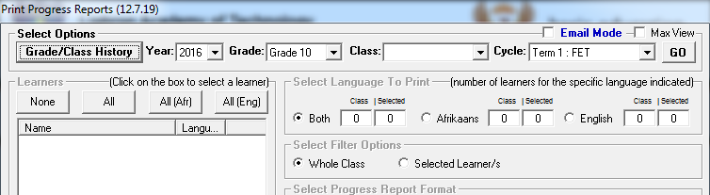
Select the grade that the learner will be in 2020.
Click on the required year.
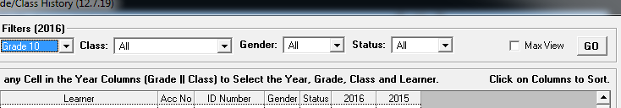
- Previous year’s schedules
- On screen 12.3.12.16 previous year’s mark schedules can be selected and printed. Available if security setting is on (Annexure B)
- Previous year’s promotion schedules can be viewed and printed from 12.9.12 and 12.9.15.
New functions available if security setting is “ON”:
F: Annexure –Promotion to be completed in 2020 for 2021 on 3.19
- Learner Promotion decisions was completed on screen 3.18. Screen 3.19 only complete the process of placing learners in a new grade.
- Step 1: Please check that the promotion statistics are shown for 2020 when opening screen 3.19. If shown the promotion has been done for the year. Do not run the promotion twice!!!!!!!!
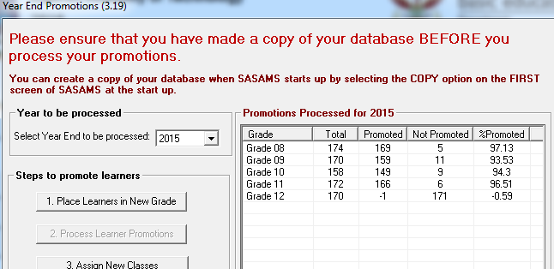
- Step 2: If the screen is blank it is an indication that the 2020 promotion was not completed, continue as follows:
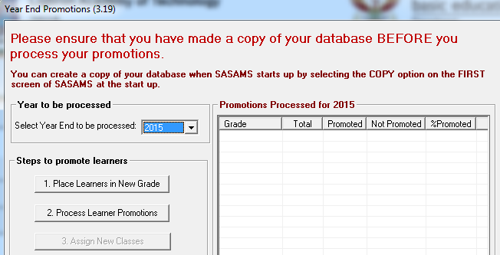
- Step 3: Click on ‘Place learners in New Grade” it will instruct you to go to “2. Process learner promotions”
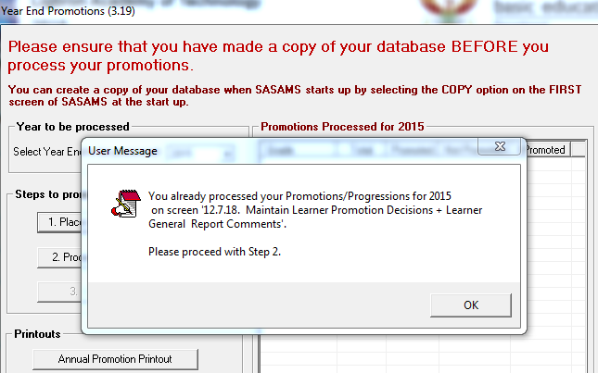
- Step 4: At the bottom tick the confirmation box and then proceed to click on “Process Promotions”
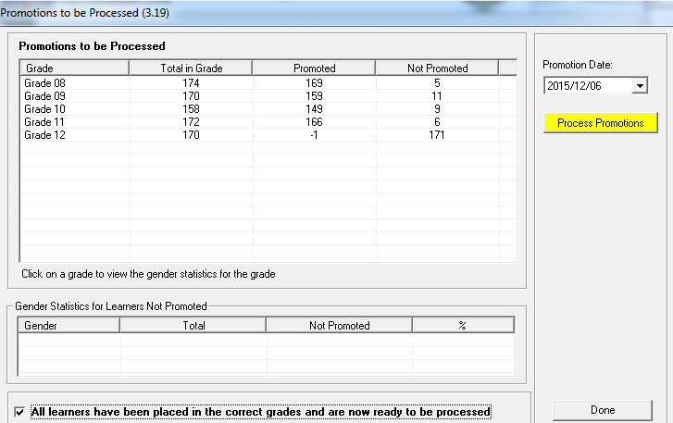
- Step 5: You will now notice that the statistics appear on the opening screen. Learners have to be assigned to new register classes.

G: Annexure B– offline capturing options if security setting is switched on
- On screen 12.3.12.15 a print option is available to print multiple class lists e.g. grade or teacher with one selection.
- On screen 12.3.12.16 previous year’s mark schedules can be printed.
- On screen 12.3.12.1 the mark schedules can be exported to excel for offline capturing and later be imported. Only tasks that are set as “open” on screen 12.3.11 will be shown here
