Background
- The National Assessment Circular 01 of 2021 contains the GET subject weightings for 2021.
- The SBA weightings is displayed as weights out of 80%
- SA-SAMS is a standard system with weighting shown as 100 %. This is to convert the SBA total to any other percentage % e.g. 100%, 80%, 75%, 60% etc.
- This guide is to show the equivalent weight numbers when converted from 80% to 100%.
The print screens contain the conversions for the following GET subjects:
 | Grade |  | Subjects : Non - Languages | Page
 | 4-6 |  | Life Skills | 1
 | 4-9 |  | Mathematics | 2
 | 4-9 |  | Social Sciences | 2
 | 4-6 |  | Natural Sciences & Technology | 2
 | 7 -9 |  | Natural Sciences | 3
 | 7 -9 |  | Economics and Management Sciences | 3
 | 7 -9 |  | Technology | 3
 | 7 -9 |  | Creative arts | 4
 | 7 -9 |  | Life Orientation | 4
Grades |  | Subject: Life Skills |  |  |  |  | Remarks
Grades 4 -6 |  | Term 1 to 3 contributes 80 % to the promotion mark.  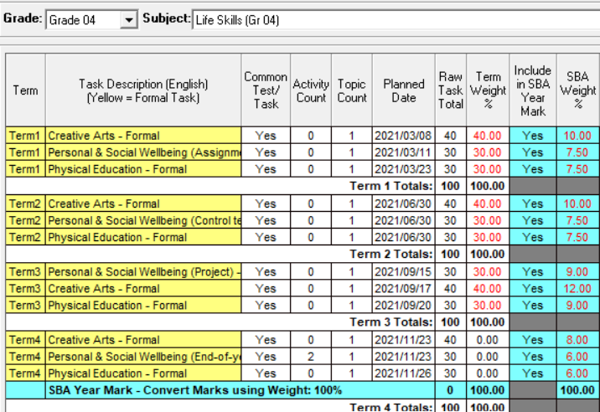  T4 20%  T1-3 80% |  |  |  |  | - SBA Weighting for as per revised ATP’s.  - Dates must be adjusted to school assessment program – also to order the tasks on the capturing sheet.  - Learner assessment scores are captured and reported per task  - A score of “-1” is captured for absenteeism (or if no assessment was done) with valid reason.  - 1 score required if “Activity Count” is 0 (1 Column of marks)  - **2 sets of scores required if “Activity Count” is 2  - Analysis marks available in different reports on 12.9 e.g.  12.9.16 Subject performance  12.9.16.8 Separated analysis for tasks if “Yes”  12.9.13 Learners at risk Top achievers
Grades |  | Subject: Mathematics |  |  | Remarks
Grade 4 -6 |  | 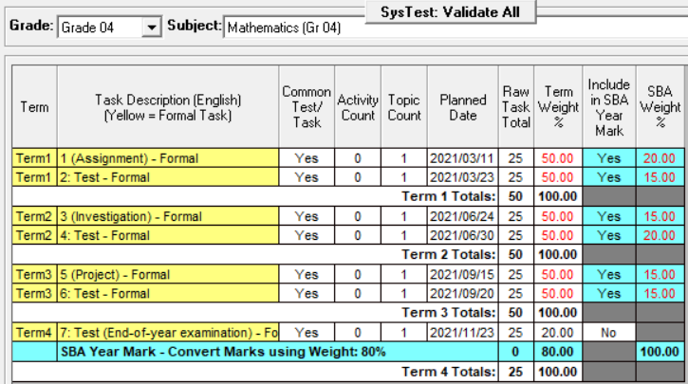 |  |  | SBA (Term 1-3) contributes 80 % to the promotion mark and is calculated as follows:  SBA 80% SA-SAMS  16 20  12 15  12 15  16 20  12 15  12 15  100% converted to 80%
Grades |  | Subject: Social Sciences |  |  | Remarks
Grade 4-6 |  | 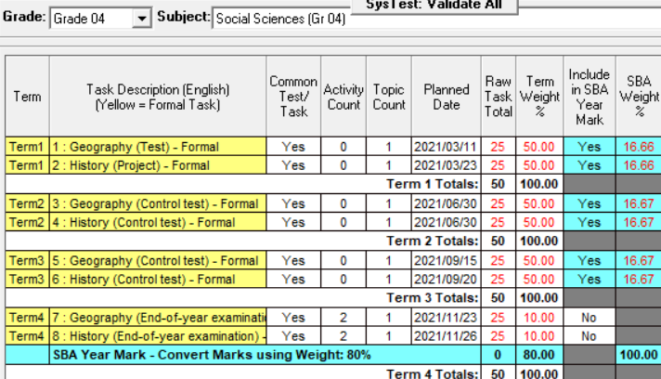 |  |  | SBA (Term 1-3) contributes 80 % to the promotion mark and is calculated as follows:  SBA 80% SA-SAMS setting  13.33 16.66  13.33 16.66  13.33 16.67  13.33 16.67  13.33 16.67  13.33 16.67  100% converted to 80%
Grades |  | Subject: Natural Sciences & Technology
Grade 4 -6 |  | 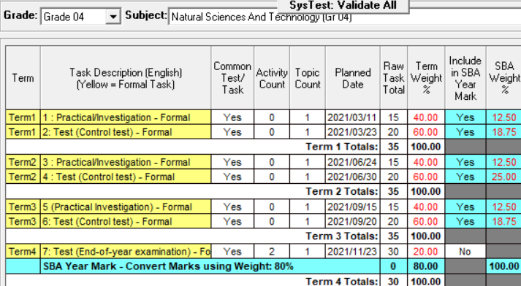 |  |  | SBA (Term 1-3) contributes 80 % to the promotion mark and is calculated as follows:  SBA 80% SA-SAMS setting  10 12.5  15 18.75  10 12.5  20 25  10 12.5  15 18.75  100% converted to 80%

Grades | Subject: Natural Sciences
Grade 7-9 | 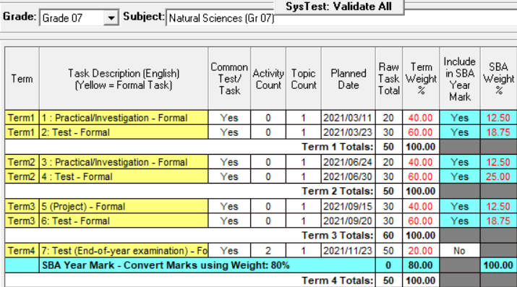 | SBA (Term 1-3) contributes 80 % to the promotion mark and is calculated as follows:  SBA 80% SA-SAMS setting  10 12.5  15 18.75  10 12.5  20 25  10 12.5  15 18.75  100% converted to 80%
Grades | Subject: Economic Management Sciences
Grade 7-9 | 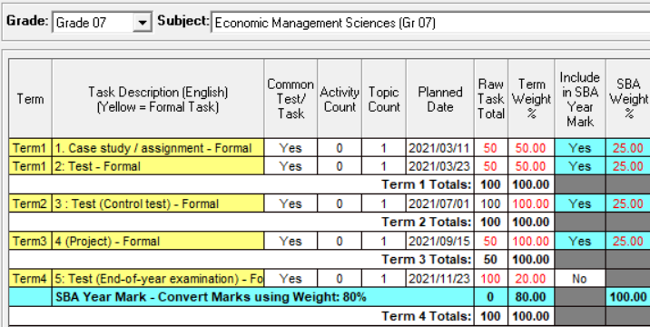 | SBA (Term 1-3) contributes 80 % to the promotion mark and is calculated as follows:  SBA 80% SA-SAMS setting  20 25  20 25  20 25  20 25  100% converted to 80%
Grades | Subject: Technology
Grade 7-9 | 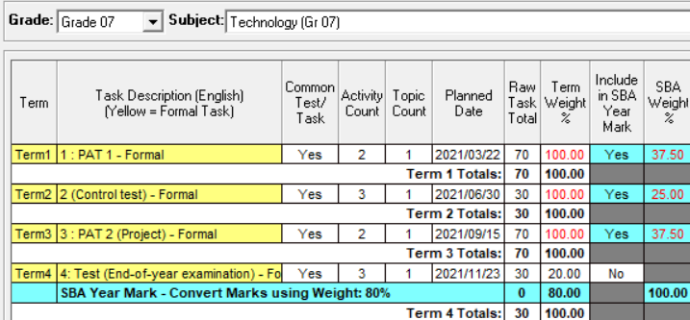 | SBA (Term 1-3) contributes 80 % to the promotion mark and is calculated as follows:  SBA 80% SA-SAMS setting  30 37.5  20 25  30 37.5  100% converted to 80%

Grades | Subject: Creative Arts
Grade 7-9 | 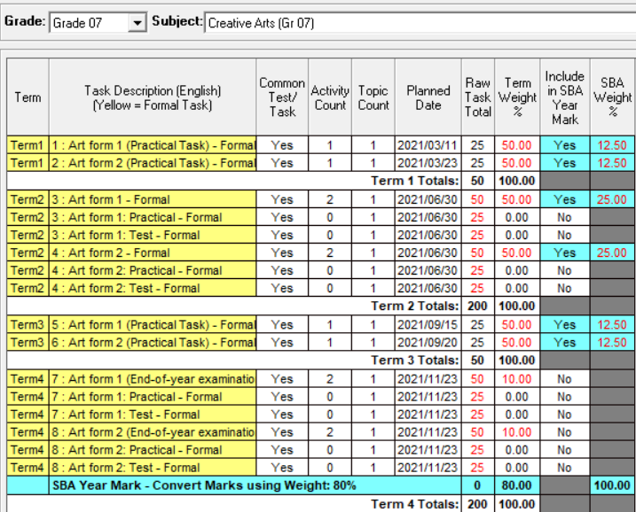 | SBA (Term 1-3) contributes 80 % to the promotion mark and is calculated as follows:  SBA 80% SA-SAMS setting  10 12.5  10 12.5  20 25  20 25  10 12.5  10 12.5  100% converted to 80%
Grades | Subject: Life Orientation
Grade 7 | 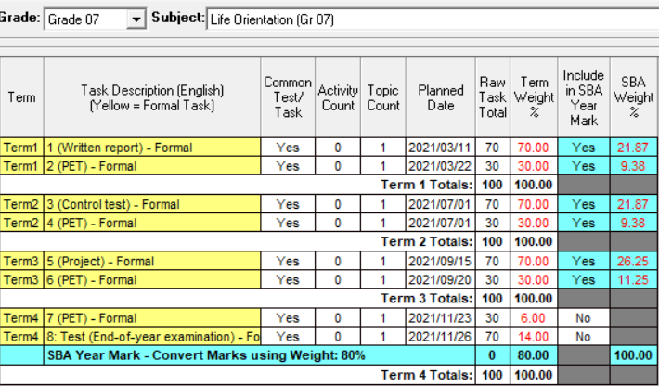 | SBA (Term 1-3) contributes 80 % to the promotion mark and is calculated as follows:  SBA 80% SA-SAMS setting  17.5 21.67  7.5 9.38  17.5 21.67  7.5 9.38  21 26.25  9 11.25  100% converted to 80%

