How to download/install SA-SAMS for the first time?
Step 1: Open your browser (Internet Explorer).
Step 2: Type in: http://www.thutong.doe.gov.za
Step 3: Select Education Administration
Step 4: On the right side under SA-SAMS Installation File, select Setup File (Installing SA-SAMS for the first time).
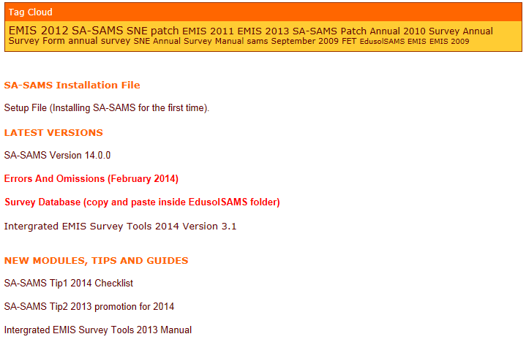

Step 5: A window will pop out at the bottom of the window select save.
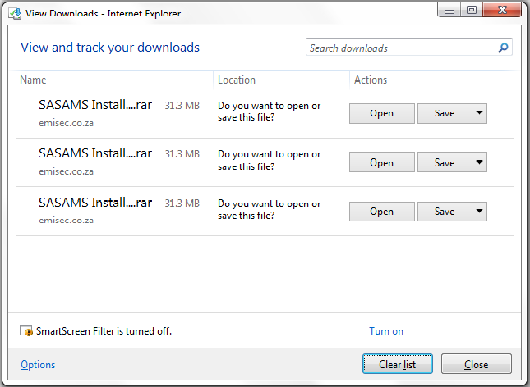
Step 6: A zipped folder will be downloaded into your downloads folder.
Step 7: Right click on the folder and select Extract Here.
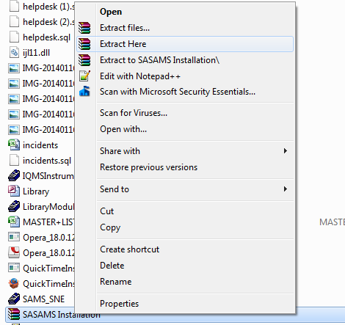
Step 8: This will create a folder named SA-SAMS Installation.

Step 9: Open the folder and click on Setup this will open the installation window. Click on OK to proceed.
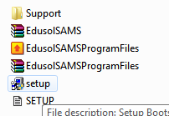
Step 10: After completion of Step 9 click on EdusolSAMSProgramFiles this will open the installation window. Click on install. This insures that all files are installed. NB: Once done you can download the latest patch and here: http://www.thutong.doe.gov.za/ResourceDownload.aspx?id=49022&userid=-1
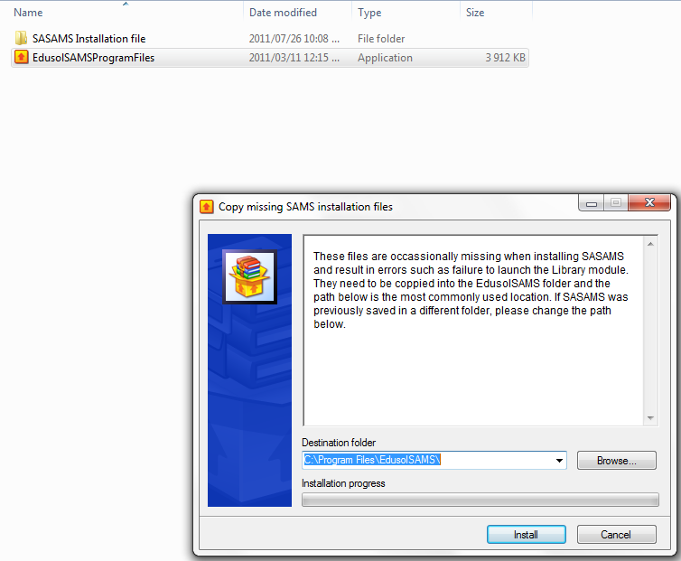

Update to latest patch:

Step 12: Go to-
http://www.thutong.doe.gov.za/Default.aspx?alias=www.thutong.doe.gov.za/administration

Step 13: On the right side under LATEST VERSIONS, double click SA-SAMS Version 17.1.0 to start download.
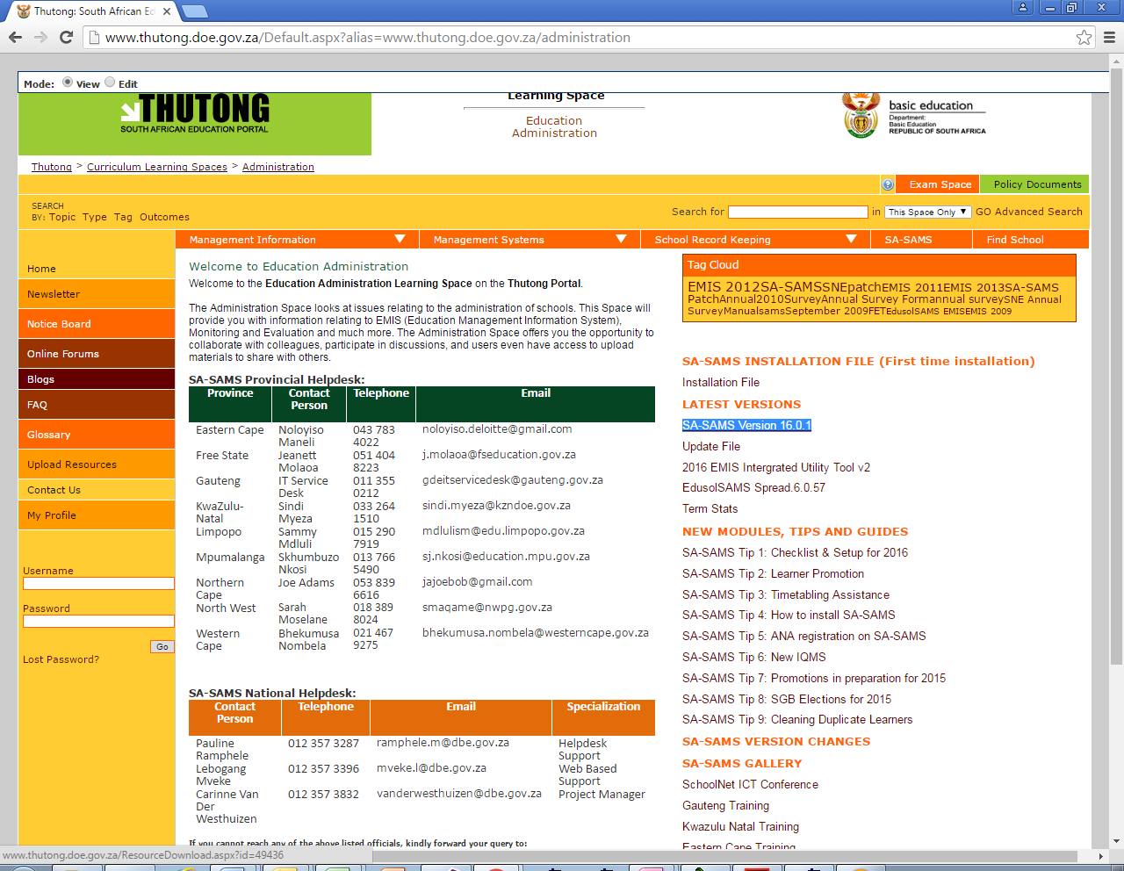
Step 14: Once download is done, extract the folder and make sure it is in the same location as your SA-SAMS installation.
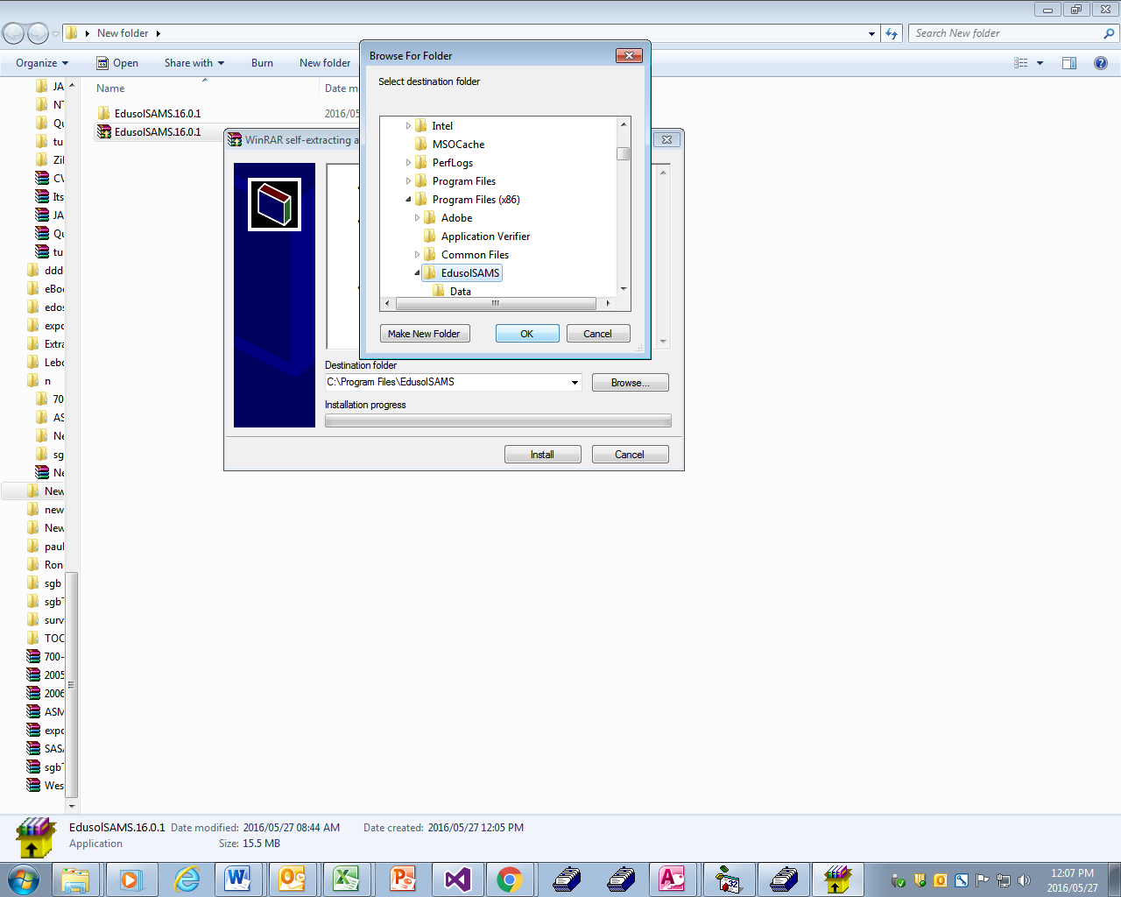
Step 15: Make your directory C:\Program Files (x86)\EdusolSAMS if you’re using 64-bit operating system, if it’s a 32-bit use the path C:\Program Files\EdusolSAMS.

Install spread:
- Step 16:
http://www.thutong.doe.gov.za/Default.aspx?alias=www.thutong.doe.gov.za/administration
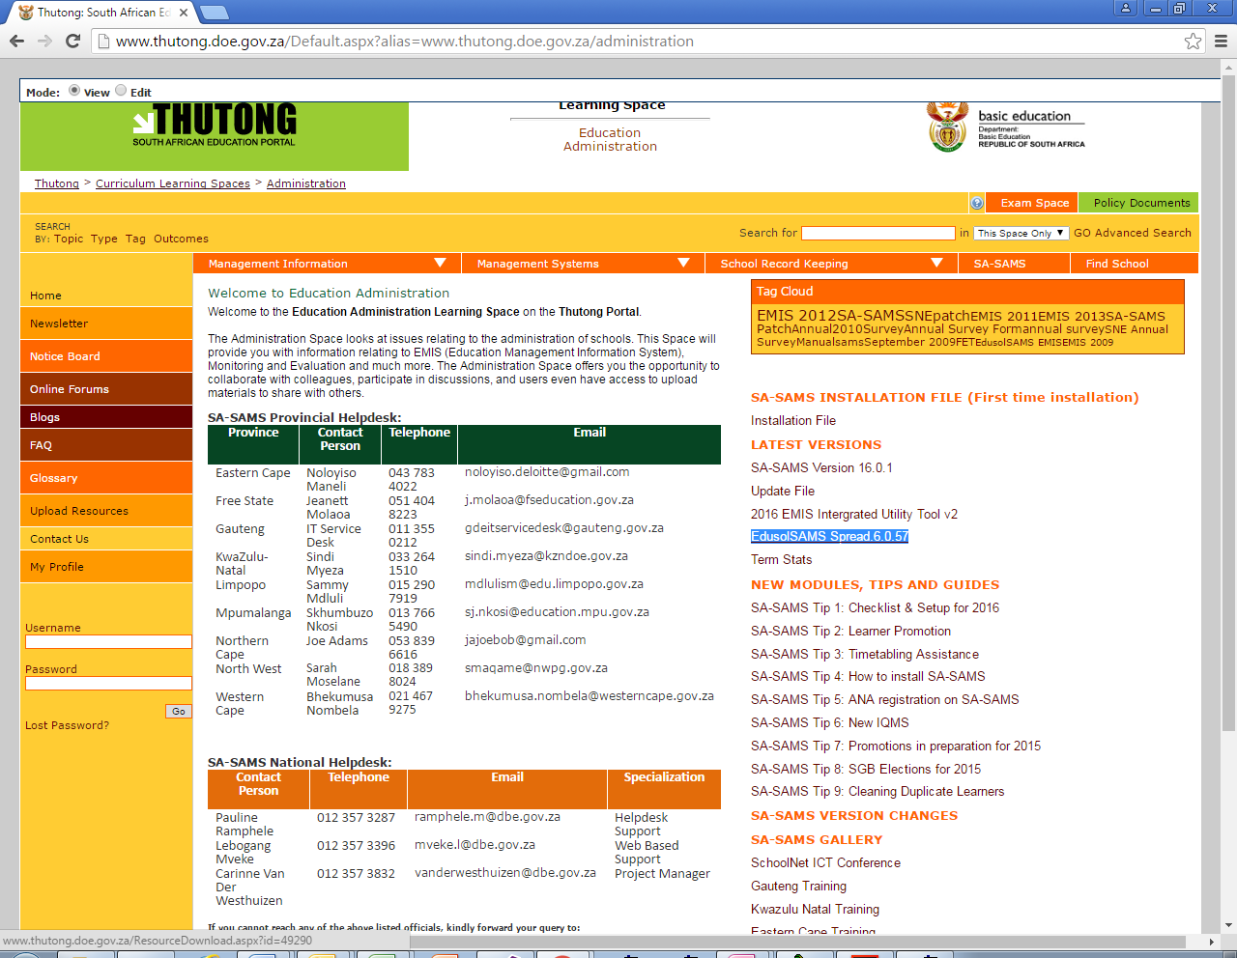
- Step 17: On the right side under LATEST VERSIONS, select EdusolSAMS Spread.6.0.57.
- Step 18: Once download is done, extract the folder and make sure it is in the same location as your SA-SAMS installation.
- Step 19: Make your directory C:\Program Files (x86)\EdusolSAMS if you’re using 64-bit operating system, if it’s a 32-bit use the path C:\Program Files\EdusolSAMS.

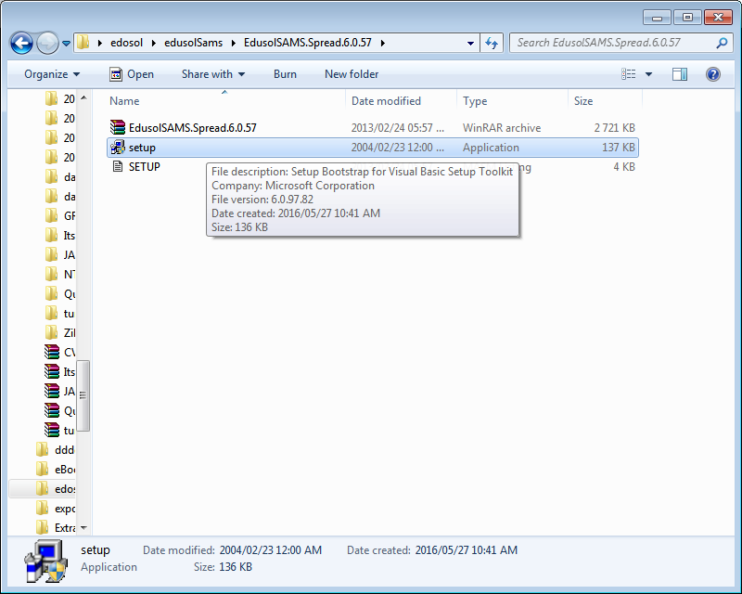

- Step 20: Double click on setup to start the installation.
- Step 21: Follow the instructions to continue with the installation.
- Step 22: Make your directory C:\Program Files (x86)\EdusolSAMS if you’re using 64-bit operating system, if it’s a 32-bit use the path C:\Program Files\EdusolSAMS.

CHECKING IF ALL FILES ARE INSTALLED CORRECTLY
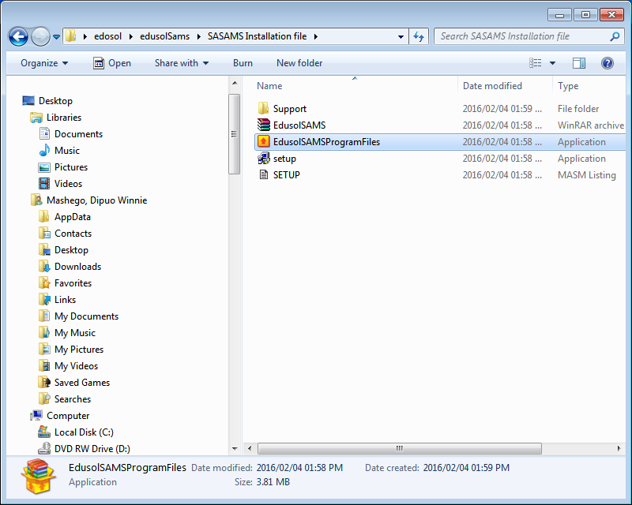
- Step 23: Double click on EdusolSAMSProgramFiles to start the installation.
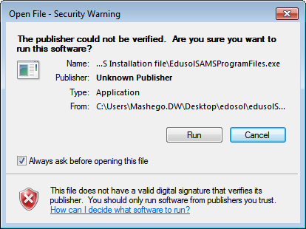
- Step 24: Click RUN to continue with the installation.

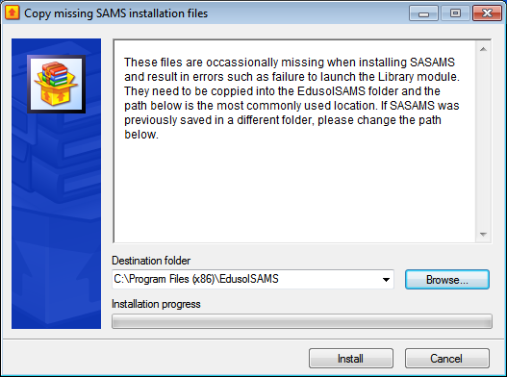
- Step 25: Make your directory C:\Program Files (x86)\EdusolSAMS if you’re using 64-bit operating system, if it’s a 32-bit use the path C:\Program Files\EdusolSAMS.
- Step 26: Click Install to continue with the installation.

