Instructions on capturing Term 3 marks of Gr 12 Life Orientation on SA-SAMS
BACKGROUND
- The settings for the tasks on Gr 12 Life Orientation Term 3 is swopped around (as shown on the diagrams below). This notice is to inform the users on how to adapt the system to capture the marks correctly.

WHAT to DO in TERM 3 and TERM 4
For Term 3: Please follow the steps to prepare for correct capturing and authentic schedules:
Step 1: On 12.3.11.
Term and Task | What to do
Term 3 Task 6 | - Add two activities under this task
Term 3 Task 7 | - On 12.3.11 Add an extra activity (called exams) under this task and change weight to 100 % for this activity  - (On 12.3.12 Because the PET activity cannot be removed “-1” will be captured in the columns for the 2 wrongly placed activities )  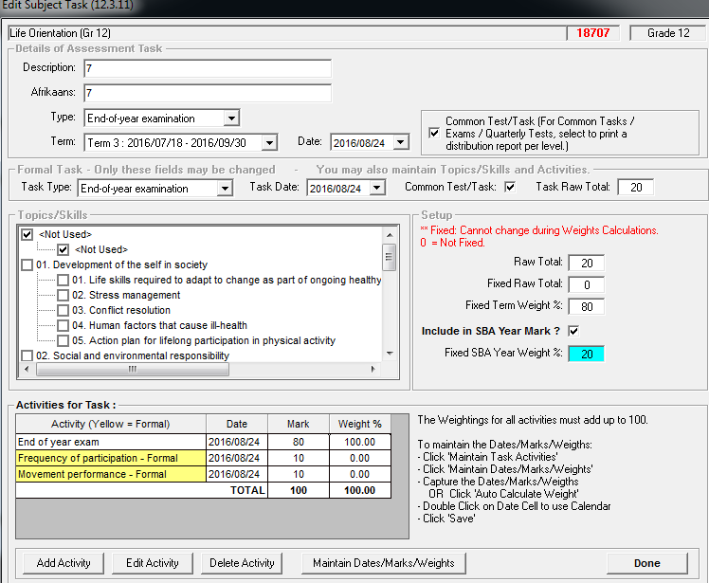

Step 2: On 12.3.11 Click on Weights/Validation -> Click on Save -> Click on Done
Before | After
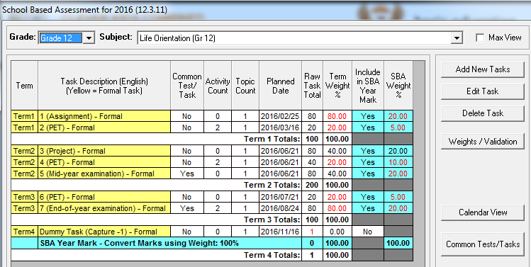 | 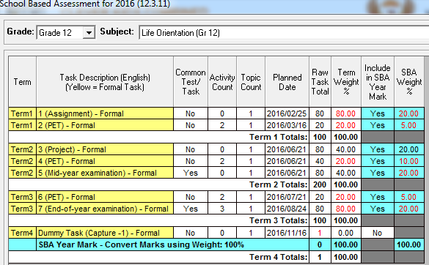
Step 3: On 12.3.12 ->Capture the marks in the columns provided -> Click on Save -> Click on Done
Step 6: On 12.7.16.3 ->Verify and send marks to Quarterly Schedules
Step 7: On 12.9.13 identify learners at risk for the subject; on 12.9.16 print analysis schedules for the subject.

For Term 4
Complete the following steps to prepare for the End-of-year SBA, promotion and analysis schedules:
Step 1: On 12.3.12 for Term 4 for the Dummy Task capture -1.
Step 2: On 12.3.12 to view and print the marks for the whole year, tick the box “ SHOW SBA Tasks”.

