INTRODUCTION
- To be fully operational, SA-SAMS needs to be correctly set-up for the New Year. The checklist provided will guide the schools to check and update the fields for 2018/19.
- Year-end promotion and roll over (3.19) need to be completed in 2018 to ensure functionality in 2019.
- The 2019 Curriculum settings will be available in version 18.2.0.
CONTENTS OF THIS TIP:
To show the steps needed to export & import marks on an excel schedule:
- A: Check list of steps to be completed on SA-SAMS for 2018
- B: Subject Updates (Available on version 18.3.0
- C: Lists and summaries for checking and verification & reports for Districts
- D: Previous year’s marks available
- E: Annexure –Promotion to be completed in 2018 for 2019 on 3.19
- F: Annexure– offline capturing options if security setting is switched on

A: Check list of steps to be completed on SA-SAMS in 2018
This checklist is designed to guide the schools to ensure that all processes are done correctly.
 | Screen | Function | Tick if checked
Learner promotion completed in 2018 | 12.7.18 | Confirm promotion decisions, identify progressed learners  Print statistical schedules (12.9.16)
 | 3.19 done once | Learners are promoted in 2018 to the new Grades for 2019  - Follow the instructions in the Annexure as this process cannot be reversed.  - This procedure is required to ensure that historical information is kept
Learner updates | 3.1.1 | Archive learners that are leaving  - Gr 7 is automatically archived
 |  | - Gr 12 is automatically archived according to SBA results. Archive Gr 12 learners now that attained their NSC.
 | 3.1.5 | Place learners in new register classes
 | 3.1.8 | Update LOLT of learners (Gr 4)
 | 12.1.15 | Assign subjects to the following learners  - learners entering a new phase  - New learners  Check for errors on 12.1.18 | Available with 18.2.0
 | 12.1.16 | Assign learners to different subject classes
 | 6.3 | Print pre-populated learner & Parent profile forms to confirm information ( Re-registration)
New Learners | 3.1.1 | Capture new learners with registration date as January 2018** under “Future learners”  - Assign subjects to the learners
Class lists | 3.1.7 | Learners’ data per register class– design and print class-lists
Educator updates | 2.1 | Assigned register classes to educators
 | 2.1 | Update teaching load for all educators
 | 12.1.16 | Assigned Educator to different subject classes | On 18.0.0
 | 16.12 | Assign Username and password for individual educators  Assign access to specific screens
 | 16.13 | Set-up access for all educators to and classes
 | 6.3 | Print pre-populated Staff profile forms to confirm information
New Educators and Staff | 2.1 & 2.3 | Capture new Educators and all non teaching staff
 | 2.1 | Educator contact list
School Logo | 1.15 | In case of a school logo with a large data size  Reduce the size of the school logo if a warning message appears on the size.
In case of no school logo
Personalize the school database by adding a school

B: Subject Updates (Available on version 18.2.0)
 | Screen | Function | Tick if checked
Setup and verify subject settings | 12.3.11 | Validating the tasks and its raw totals and weights  by HOD and subject teacher
 | 12.3.15 -16 | Calendar of Tasks
Access control to classes | 16.13 | Access assigned to subject teachers per class
 | 16.13 | Access assigned to HOD and Principals
 | 16.13 | Change robot to green to activate the access control.
Open tasks for capturing of marks | 12.3.11 | For all subjects change the task status to “open” for capturing
 | 12.3.12.1 | Export subject lists for remote capturing

C: Lists and summaries for checking and verification & reports for Districts during the year
 | Screen | Function | Tick if checked
2018  Learner promotion | 12.9.15 | Promotion schedules
 | 12.9.16 | Analysis schedules
Learner data | 3.1.7 | Summary report (SNAP & Head count)  (Class, learner numbers , educator and class room)
 | 3.1.6 | Learners’ data per register class– design and print class-lists
 | 12.1.16  12.3.12 | Teacher load and  Class lists per subject
 | 3.15  12.1.18 | Subject enrolments
 | 3.1.1 3.16 | Gr 12 Exam registration
Staff data | 2.9 and 2.19 | Educator data list
 | 2.3 , 2.19 | Staff data list (NSNP and other)
D: Previous year’s marks available
- Learner reports
Select “Grade/Class History” screen 12.7.19
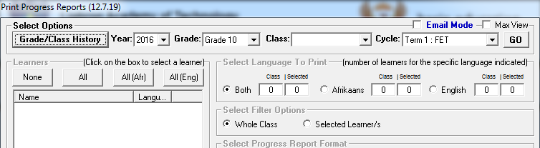
Select the grade that the learner will be in 2018.
Click on the required year.
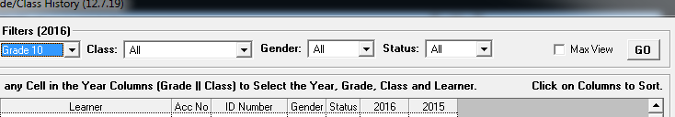
- Previous year’s schedules
- On screen 12.3.12.16 previous year’s mark schedules can be selected and printed. Available if security setting is on (Annexure B)
- Previous year’s promotion schedules can be viewed and printed from 12.9.12 and 12.9.15.
New functions available if security setting is “ON”:

