SA-SAMS assisting schools with SGB elections
Functionalities on SA-SAMS assist schools with printing a voter’s role and capturing of members and all policies and documents transferred to the new School Governing Body as well as printing a composition list of the new SGB.
- Printing a Voters role
- A Voter’s role for parents can be printed on 3.1.12. Click on “View for whole family” to print list for whole school. The list links the learners and associated parents. The list can be printed or exported to add more columns.
An alternative available list is 3.1.11 option “Parent per Family printout”.
Parent ID numbers are available on 3.1.11 option “Parent with learners” for matching.
- A Voter’s role for educators and non-educating staff members can be printed from the contact lists on 2.1 and 2.3.
- A Voters role for captured RCL learners can be printed on 3.1.1 or 4 (select RCL and then print composition list at the bottom)
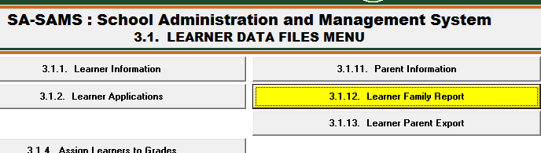
e.g. for parents

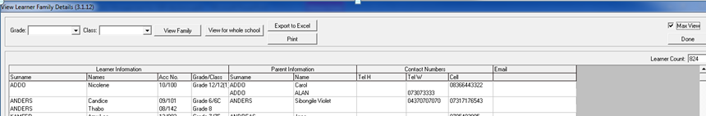

B: Administration of Board members SCC and Transfer of school documents needed for reporting
The following functions are available to capture board members and for printout lists:
5.1.1 - Capturing of Governing Body members (All members must be captured before submitting the school database for Annual School Survey. Membership must be changed to “no” for members that stepped down)
5.1.11 - Composition register printout (Submit the copy that is signed by the principal and SGB Chairperson signed, with a school stamp to the district)
5.3.1 - Capturing Safe School Committee members (All members must be captured before submitting the school database for Annual School Survey. Membership must be changed to “no” for members that stepped down. Remember to complete the Police member’s form)
5.1.3 - Training required must be captured for each member.
5.1.3 – Adoption of the School’s Policies at the AGM must be captured for school reporting.
